Task 1
Digital Literacy Awareness Infographic
Module 1 | 20 Marks

Name | Aaradhya Singhai
Registration No. | 25MEI10078
Branch / Year | Integrated MTech CSE – Cybersecurity | First Year
Course Code | CSE0001 – Digital Literacy
Date | 29 March 2026

Task Overview
As a Student Digital Ambassador, you need to create a one-page visual resource helping batchmates understand what Digital Literacy means and why it matters. This document contains the task description, your design notes, and the completed infographic submission.

Infographic Details

Tool Used
Canva (canva.com) — a free, browser-based graphic design platform with drag-and-drop functionality and an extensive library of templates and icons.

Topics Covered in the Infographic
- What Digital Literacy Is — definition, importance for students in today's world
- Safe Internet Practices — strong passwords, avoiding phishing, protecting personal data
- Professional Online Presence — building credibility on LinkedIn and GitHub

Design Description
The infographic uses a clean two-column layout with contrasting colour blocks — deep blue for headers and soft white/grey for content areas. Each of the three topics is represented by a distinct icon-led section with concise bullet points beneath a bold heading. The visual hierarchy guides readers from the definition of digital literacy at the top, through practical safety tips in the middle, and ends with guidance on building a professional online identity.
A consistent colour palette (blue, white, and orange accents) was chosen to ensure the infographic looks professional and is easy to scan at a glance. All text was kept brief so that the design could function as a standalone poster or handout.

Reflection (150–200 words)
I created the Digital Literacy Awareness Infographic using Canva, which I found to be an intuitive and powerful tool even for someone with no design background. I chose Canva because of its large library of free templates specifically designed for educational infographics, and because it allows exporting in multiple formats including PNG and PDF for easy sharing.
My infographic covers three key areas: what digital literacy is, safe internet practices, and building a professional online presence. I used icons, colour coding, and minimal text to make the content accessible to a first-year student audience who may be encountering these ideas for the first time.
The most interesting challenge I faced was balancing the amount of information — the first version of my design was too text-heavy and looked cluttered. I had to cut sentences down to key phrases and let the icons carry some of the explanatory weight. This taught me a valuable lesson about visual communication: less is often more, and white space is not wasted space. Overall, this task made me appreciate how design thinking overlaps with effective teaching.

Submission Checklist
- Infographic exported as PNG/PDF and added to task-1-presentation/ folder
- Canva design link noted below (share link from Canva)
- Reflection write-up completed above
- Task-1 folder present in GitHub repository

Canva Design Link
https://www.canva.com/design/DAHFTjaUXao/Wy6-gdkUkK7uUEQe3mbKxw/edit?referrer=https%3A%2F%2Fwww.canva.com%2Fs%2Fdesigns
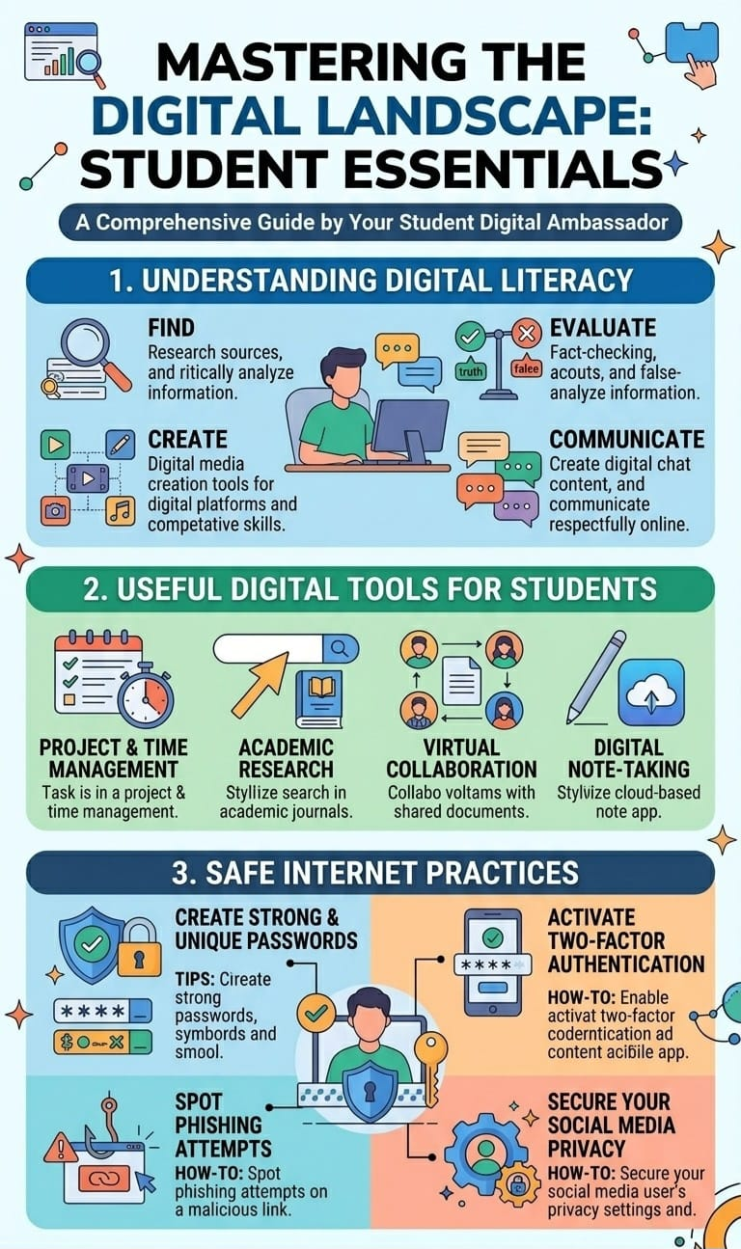

Repository: https://github.com/aaradhyasinghai-ux/Digital-Literacy-Project

